**\*\*\*Paper#(24)\*\*\***

🡪 In the first step one moving average filter by the length of 7 was used for filtering the ECG signal and then DWT

(Symlets as it Mother Wavelet) is applied to the ECG signal (decomposed in 9 levels). In order to Remove Baseline we set

the approximation coefficients to zero for tenth index and

above, and for removing high frequency noise we set the

second index of approximation coefficient and above to zero.

Then we use Butterworth filter with cutoff frequency of

40HZ in order to filter the signal and after filtering we

normalize the output. We will use the derived signal by the

operations done for feature extraction and to find the exact

location of the P, R and S points.

🡪 For deriving the exact location of S on the time axis

a method based on slope and gradient has been used [10] and

for derivation of Q location we have used thresholding method

on the slope, amplitude and the occurring time of the Q point.

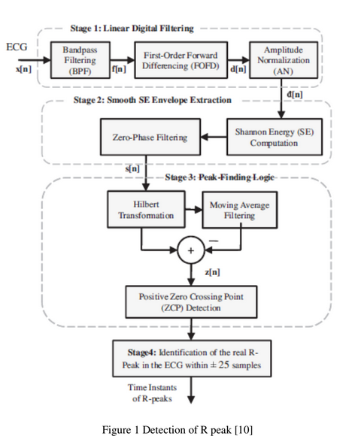

**\*\*\*paper#(25)\*\*\***

🡪 the preprocessing consists of baseline wander correction and band-pass filtering. The raw ECG signal was first processed to correct the baseline wander using a wavelets-based approach.

🡪 Given the sampling rate of 360 Hz, each heartbeat segment consists of 100 samples before the R peak location as the pre-R segment, and 200 samples after the R peak as the pro-R segment.

🡪 WT is used as a feature extraction method.

**\*\*\*paper#(23)\*\*\***

🡪 segmentation using The Pan-Tompkins algorithm.

🡪the features of heartbeats are extracted by the PCANet algorithm .